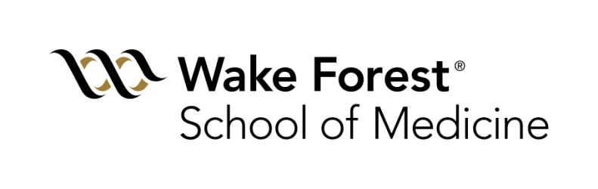

**Department of Biostatistics and Data Science**

**Biostatistician (MS and BS) Positions**

**Winston-Salem, North Carolina**

<https://school.wakehealth.edu/Departments/Public-Health-Sciences>

Twitter/X: @WakeBDS, @WakeForestMed

The Department of Biostatistics and Data Science in the Division of Public Health Sciences at Wake Forest School of Medicine is recruiting to fill multiple biostatistician positions. A master’s degree in biostatistics, statistics, epidemiology, bioinformatics, statistical genetics, or a related field is preferred, but candidates with a Bachelor’s degree in statistics/biostatistics or mathematics and strong analytic skills will be considered. Excellent verbal and written communication skills are required. Responsibilities include collaborating with medical investigators on the design, conduct, analysis, and presentation of single- and multi-center research projects and clinical trials. Experience with consulting and statistical programming, especially SAS, Python and/or R, are preferred. Experience with genetic and genomics data is preferred. Experience with a high performance computing environment is preferred.

The Department of Biostatistics and Data Science is a vibrant academic unit comprised of 25 faculty and almost 90 staff including biostatisticians, programmers, project managers, and administrative staff. This group has demonstrated long-standing growth in extramural funding, aiding the development of a rich research environment and facilitating advancements in a variety of public health disciplines including geriatrics, cardiovascular disease, diabetes, women’s health, population genetics, and cancer control. The Department resides within the Division of Public Health Sciences, which also includes the Department of Epidemiology and Prevention, the Department of Social Sciences and Health Policy, and the newly formed Department of Implementation Science. Together, Public Health Sciences is the largest research group at Wake Forest, including more than 60 faculty and 240 staff.

Our department engages in data science work with collaborative teams spanning academic, governmental, and industry organizations. Our main research areas are aging, Alzheimer’s disease and related dementias, diabetes, cardiovascular and public health. We often deal with large datasets generated by clinical trials, available to the public or in the medical records system including imaging, omics, wearable devices, etc. Data Science is constantly evolving, and we are also continually developing and expanding our work, including in the areas of clinical trials, biostatistics, machine learning, artificial intelligence, new software platforms and high-performance computing.

Located in the Innovation Quarter (https://www.innovationquarter.com/) adjacent to Bailey Park (<http://baileyparkws.com/>) in downtown Winston-Salem, NC, Wake Forest University School of Medicine is the cornerstone of one of the fastest-growing urban-based districts for innovation in the United States. A city of approximately 220,000 people, Winston-Salem is home to Atrium Health Wake Forest Baptist Medical Center and Wake Forest University. The city is nestled in the northwestern region of North Carolina, within easy driving distance to the beautiful Blue Ridge Mountains and the pristine beaches of North Carolina.

We celebrate diversity and are committed to creating an inclusive environment for all employees. We promote diversity of thought, culture and background, which connects the entire Atrium family. Applicants may apply directly at the following link:

<https://emis.fa.us2.oraclecloud.com/hcmUI/CandidateExperience/en/sites/CX_1001/job/120555/?utm_medium=jobshare>

Or by sending a cover letter, graduate school transcript, and curriculum vitae to [dbsrecruit@wakehealth.edu](mailto:dbsrecruit@wakehealth.edu). Employer will assist with relocation costs.

Wake Forest Baptist Medical Center is an Affirmative Action and Equal Opportunity Employer with a strong commitment to achieving diversity among its faculty and staff. EOE/AA: Minorities/Females/Disabled/Vets. Atrium Wake Forest Baptist is an equal opportunity employer.